***How to Use Jasypt in Spring Boot Application***

**Add Dependency:**

<!-- https://mvnrepository.com/artifact/com.github.ulisesbocchio/jasypt-spring-boot-starter -->  
<dependency>  
 <groupId>com.github.ulisesbocchio</groupId>  
 <artifactId>jasypt-spring-boot-starter</artifactId>  
 <version>3.0.4</version>  
</dependency>

<!-- https://mvnrepository.com/artifact/com.github.ulisesbocchio/jasypt-maven-plugin -->  
<dependency>  
 <groupId>com.github.ulisesbocchio</groupId>  
 <artifactId>jasypt-maven-plugin</artifactId>  
 <version>3.0.0</version>  
</dependency>

**Open Terminal and Use This Command:**

**Only Password Encryption**

**Encryption Command:**

mvn jasypt:encrypt-value -Djasypt.encryptor.password = iSTELAR -Djasypt.plugin.value = BALOCKER

**Decryption Command:**

mvn jasypt:decrypt-value -Djasypt.encryptor.password = iSTELAR -Djasypt.plugin.value = 1W7XdjZt9IriNPeuTWrVXBBW8qhVqAoJE8KJhWTITnePTmjGFGAVUc7b9o7cDpVa

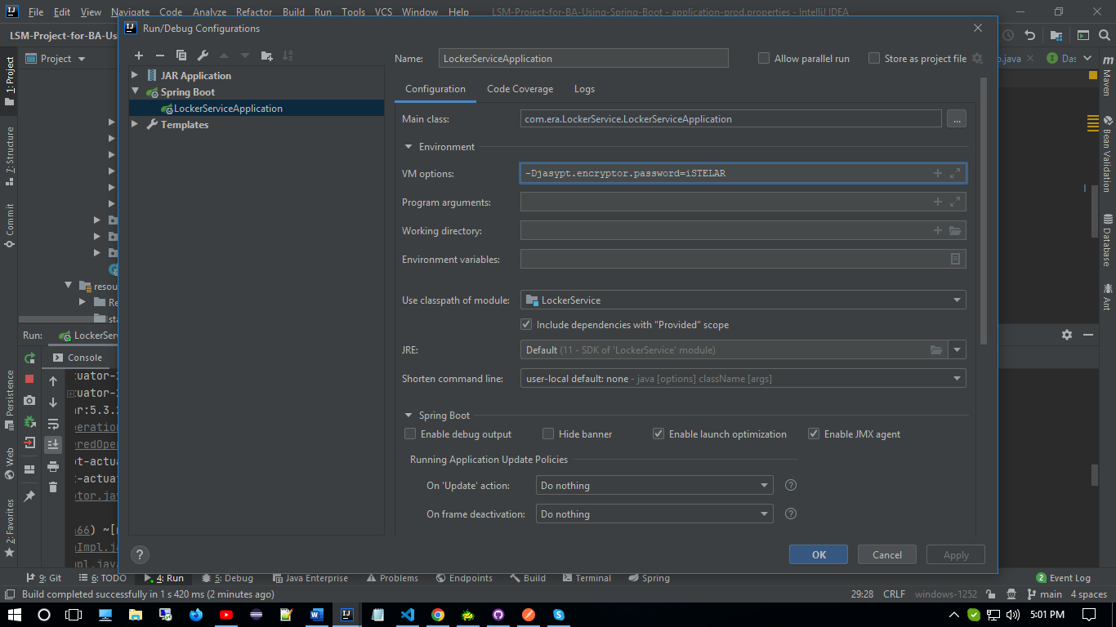

**User Name & Pass Encryption**

Application.properties file:



**Use this command in terminal: -**

mvn jasypt:encrypt -Djasypt.encryptor.password = iSTELAR

Auto Change Application properties file: -

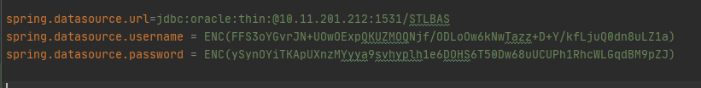

**IF USE APPLICTION.YML FILE**

**Encryption Command:**

mvn jasypt:encrypt-value -Djasypt.encryptor.password = iSTELAR -Djasypt.plugin.path = “file:src/main/resources/application.yml”

Encrypt user name & password



**IF SOMEONE CONFIG JASYPT:**

@Configuration  
public class JasyptEncryptionConfig {  
  
 @Bean(name ="jasyptStringEncryptor" )  
 public StringEncryptor passwordEncryptor(){  
  
 PooledPBEStringEncryptor encryptor = new PooledPBEStringEncryptor();  
 SimpleStringPBEConfig config= new SimpleStringPBEConfig();  
 config.setPassword("iSTELAR"); //Encryptor 's private Key  
 config.setAlgorithm("PBEWITHHMACSHA512ANDAES_256");  
 config.setKeyObtentionIterations("1000");  
 config.setPoolSize("1");  
 config.setProviderName("SunJCE");  
 config.setSaltGeneratorClassName("org.jasypt.salt.RandomSaltGenerator");  
 config.setStringOutputType("base64");  
 encryptor.setConfig(config);  
 return encryptor;  
 }  
}